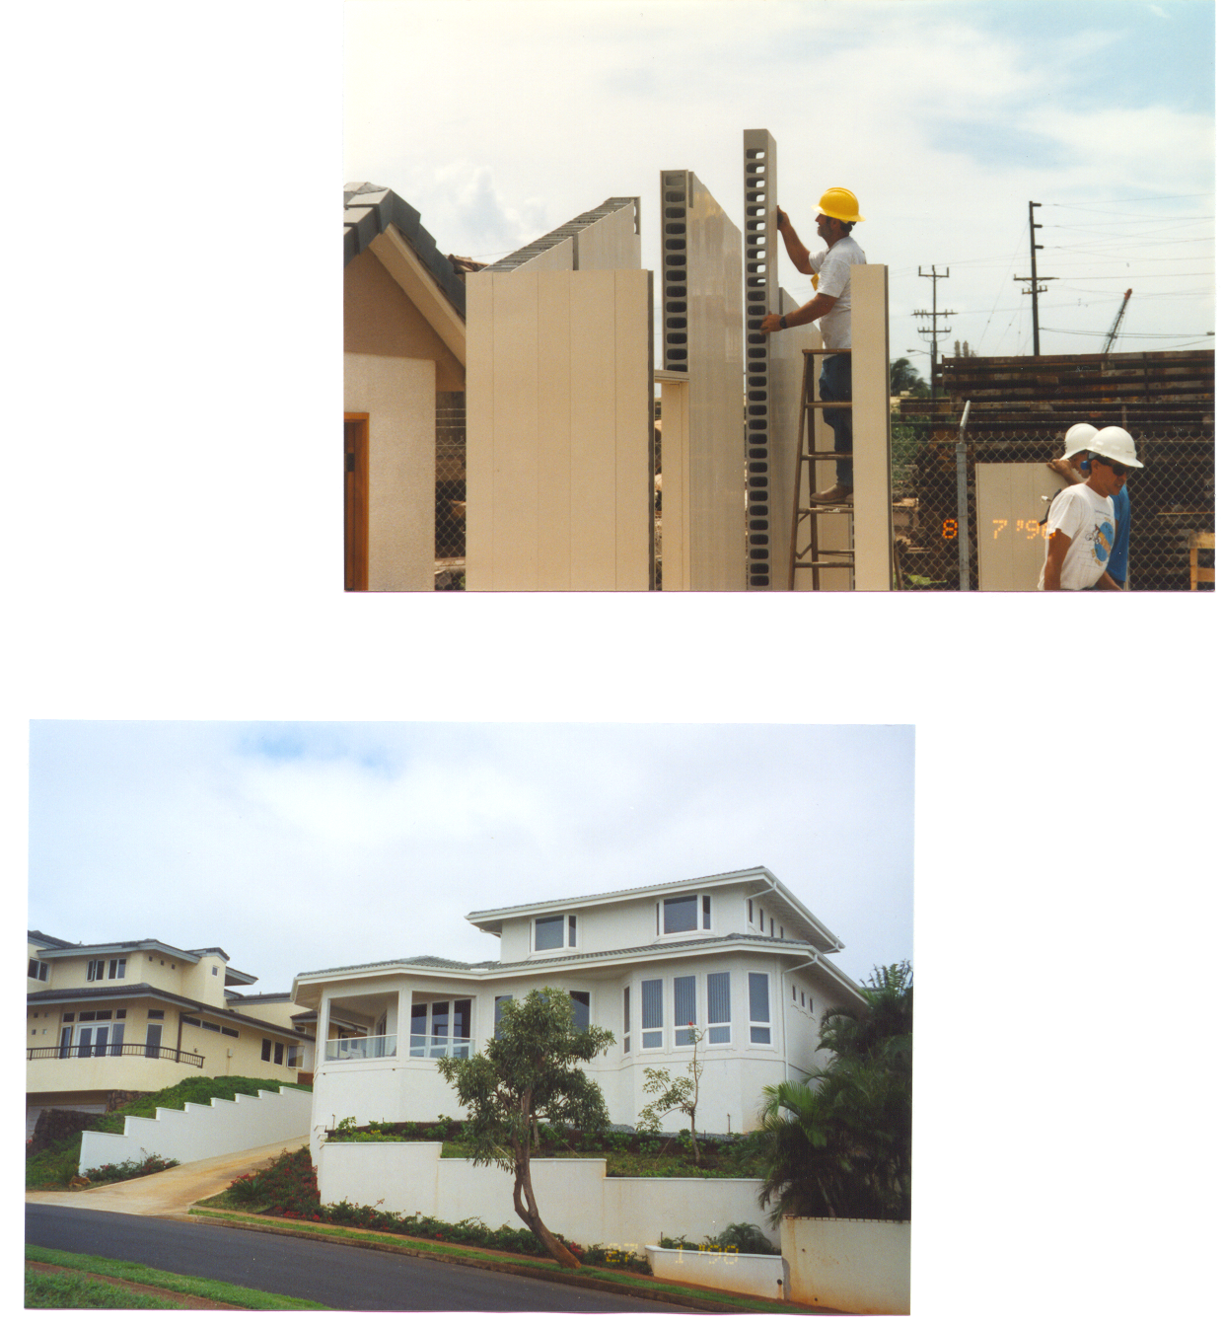

ROYAL BUILDING TECHNOLOGIES

Stay-in-Place Forms for Concrete Construction

COMBINES the strength of CONCRETE with the durability and versatility of advanced polymer technology

RBS FORMS per sq. ft.:
- 2 ½” 3.75
- 4” 5.00
- 6” 6.35
- 8” 8.50
- 8” insulated 9.50
Based on 40’ containers, shipped to Honolulu port.
Prices effective until 8.31.03

- RBS4 (4”) used for first floor structural walls.
- RBS6 (6”) used for retaining walls.
- Stucco finish easily applied.
- UV protected
- Engineering & Construction info can be downloaded from www.rbsdirect.com
- ICBO approved
- Also Available:
- Royal Crown Fencing
- Patio Covers
- Trim by Royal Moulding
- Columns
Model located at HAWAIIAN CEMENT, CAMPBELL INDUSTRIAL
HAWAII LOA RIDGE

The Royal Building System™ begins with interlocking, hollow, polymer panels that can create a wall of any length. The panels act first as forms to receive the concrete, then remain in position for the life of the home, providing polymer surfaces inside and out. The panels are cored to allow for horizontal and vertical integration and steel reinforcement, where necessary. The Royal Building System™ has been erected in over 40 countries worldwide and can be designed to withstand typhoons, earthquakes, is termite resistant and energy efficient. Also resistant to rust, rot and mildew. Ideal for below grade construction and retaining walls.
Attractive PVC fencing, decking, columns and trim also available.

Residential - Commercial - Industrial - Institutional
Royal Systems Hawaii, Inc.
683 Auahi Street, Bldg. # 300, Honolulu, HI 96813
Phone: (808) 521-0150 Fax: (808) 521-0153 E-mail: Royal3hi@aol.com
www.royalsystemshawaii.com
www.rbsdirect.com
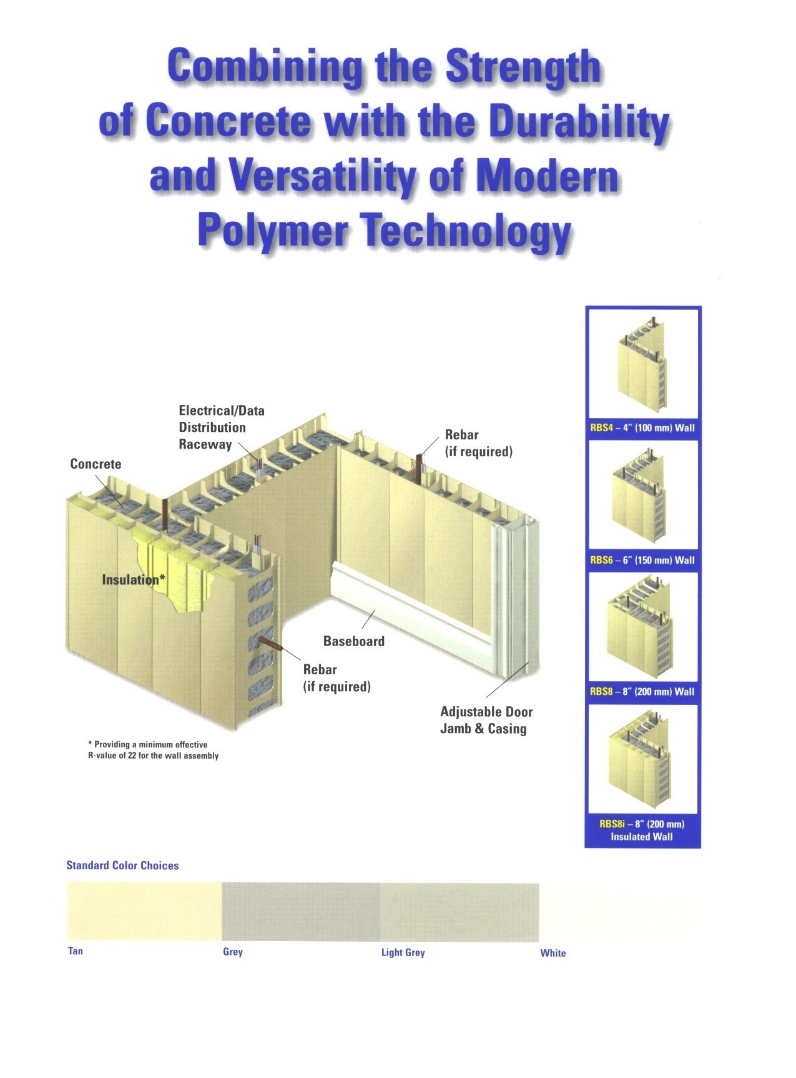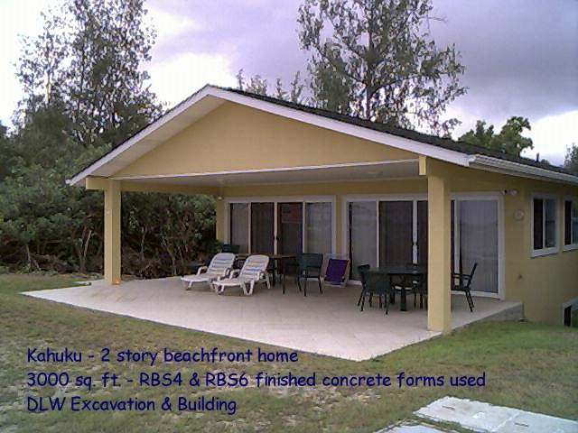
CUSTOM-CUT, STAY-IN-PLACE FORMS FOR CONCRETE CONSTRUCTION
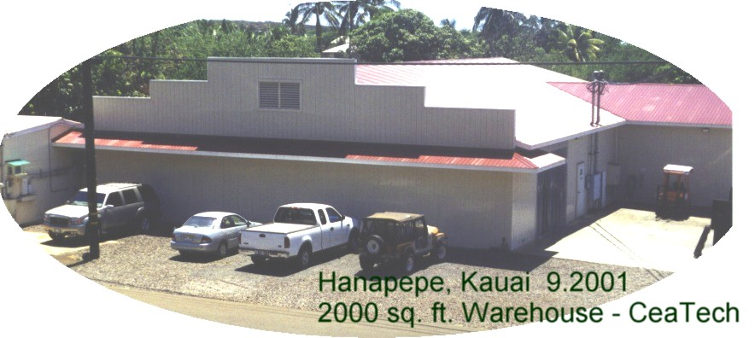

DECREASE CONSTRUCTION TIME AND INCREASE YOUR BOTTOM LINE

~ resistant to rust, rot and mildew ~
~ designed to withstand typhoons & earthquakes ~
~ solid concrete construction ~ engineered and modular components ~
~ autocad wall program, engineering and construction specifications available ~
~ ICBO APPROVED ~
Royal Systems Hawaii, Inc.
683 Auahi Street, Honolulu, HI 96813 Office: (808) 521-0150 e-mail: Royal3hi@aol.com

Website: www.rbsdirect.com and www.royalcrownltd.com
1

